Implementation Plan

Our smart light is designed with the target audience of students and those who work from home. With this in mind we added a clock feature to make it more attractive to these audiences.

Most People have a clock and a lamp on their desk which takes up space, With out design we combine both of these with additional quality of life features.

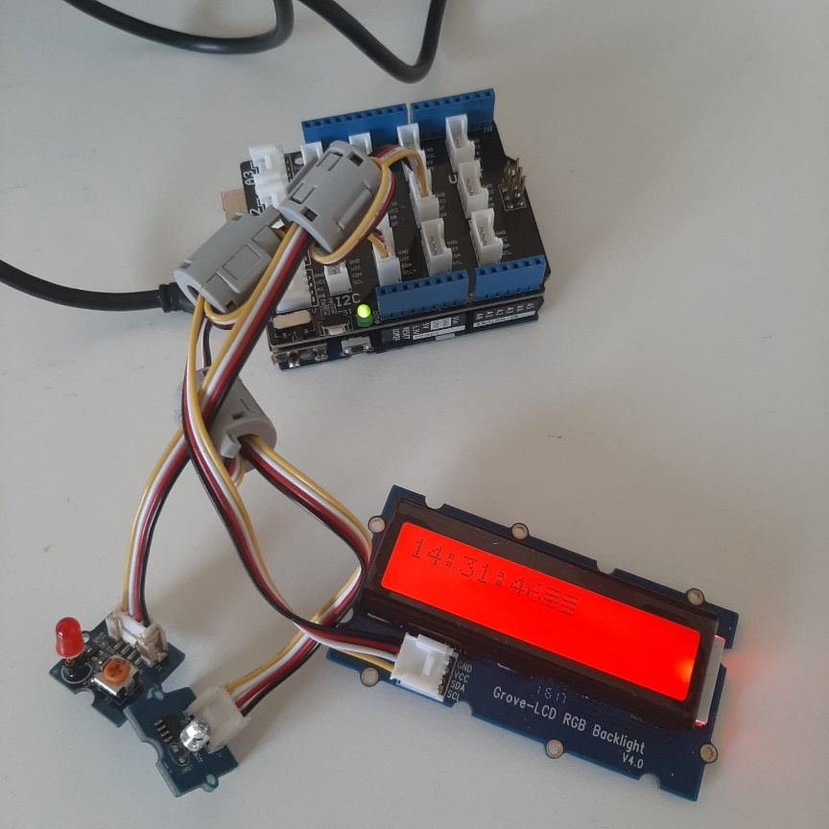

The great thing about our design is it does not require many parts to function

Parts List:

* Laptop / Desktop PC
* Arduino Yun
* Light Sensor
* LED Light
* LCD Screen

No additional equipment was needed other than the “Grove Kit”

Additionally we do not use any APIs which helped keep the code smaller and more secure

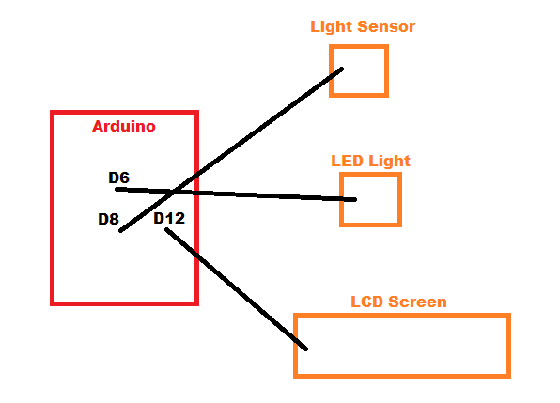

Code Samples

This section of code allows us to view what level of light the sensor is picking up, Allowing us to pick the correct level for the light to turn off and on at:

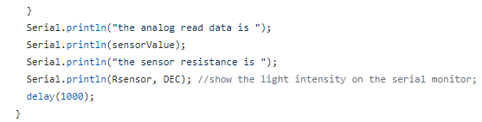

This section turns the LED of and on depending on the light levels:

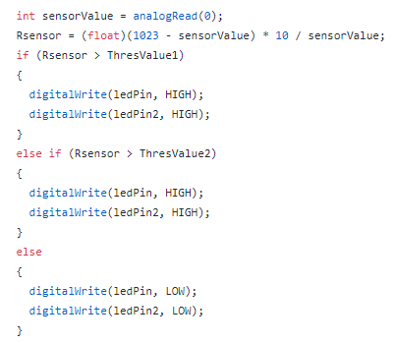

This is what tells the Arduino the time so it can display it on the LCD Screen:

